**Mini-project Computer Graphics**

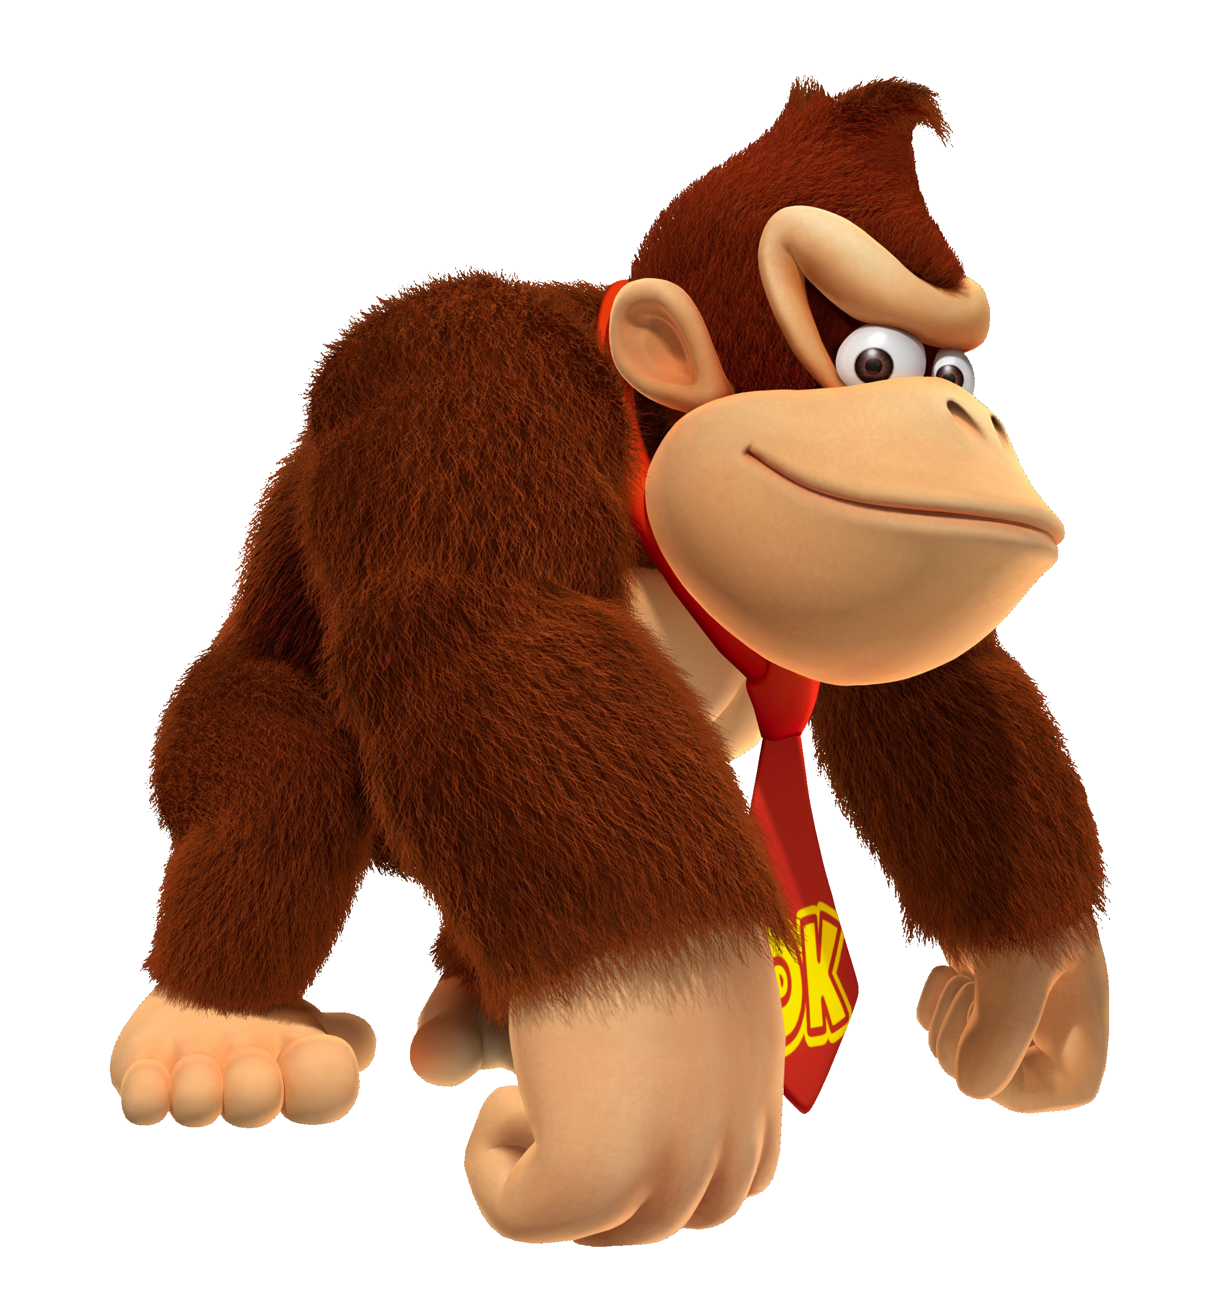

*Group 6 – Donkey Kong*

Jarco de Jong

Laurens Weijs

Mats Mulder

# Group members:

Jarco de Jong - jarco1995@hotmail.com

Laurens Weijs - Laurensweijs@gmail.com

Mats Mulder – [Mats.Mulder@live.nl](mailto:Mats.Mulder@live.nl)

# Game description:

The main target of the game is to save the princess out of the hands of Donkey Kong. To reach the princess you have to move Mario over the bars and climb the ladders to get on higher bars. Meanwhile Donkey Kong will try to hit you with barrels. These barrels will roll down the bars and the game will be over if you hit one of them. Luckily Mario is able to jump over the barrels by pressing the spacebar. Points can be rewarded by jumping over barrels and by picking up attributes.

# Game controls:

|  |  |
| --- | --- |
| Arrow Left | Move Mario to the left |
| Arrow Right | Move Mario to the right |
| Arrow up | Move Mario up on ladder |
| Arrow down | Move Mario down on ladder |
| Spacebar | Jump |
| Double spacebar | Double jump |
| P | PauseMenu |

# Externel assets used: